Practical
Exam

Making science together!

2019-07-24

General instructions
- This practical booklet contains 27 pages.
- Before the start of the practical exam, the Read command is given. You will have 15 minutes to read the exam booklet. You may only read during this time; do not write nor use the calculator.
- You may begin working as soon as the Start command is given. You will then have 5 hours to complete the exam.
- You may work on the tasks in any order, but starting with problem P1 is advised.
- All results and answers must be clearly written in pen in their respective designed areas on the exam papers. Answers written outside the answer boxes will not be graded.
- If you need scratch paper, use the backside of the exam sheets. Remember that nothing outside the designed areas will be graded.
- The official English version of the exam booklet is available upon request and serves for clarification only.
- If you need to leave the laboratory (to use the restroom or have a drink or snack), raise the appropriate card. A lab assistant will come to accompany you.
- Shelves above the benches are not to be used during the task for the purpose of equality.
- You must follow the safety rules given in the IChO regulations. If you break the safety rules, you will receive only one warning from the lab assistant. Any safety rule violation after the first warning will result in your dismissal from the laboratory and the nullification of your practical examination.
- Chemicals and labware, unless otherwise noticed, will be refilled or replaced without penalty only for the first incident. Each further incident will result in the deduction of 1 point from your 40 practical exam points.
- The lab supervisor will announce a 30 minutes warning before the Stop command.
- You must stop your work immediately when the Stop command is announced. Failure to stop working or writing by one minute or longer will lead to nullification of your practical exam.
- After the Stop command has been given, the lab supervisor will come to sign your answer sheet.
- After both the supervisor and you sign, place this exam booklet in the envelope and submit it for grading together with your product and thin-layer chromatography (TLC) plates.
Lab rules and safety
- You must wear a lab coat and keep it buttoned up. Footwear must completely cover the foot and the heel.
- Always wear safety glasses or prescription glasses when working in the lab. Do not wear contact lenses.
- Do not eat or drink in the lab. Chewing gums are not allowed.
- Work only in the designated area. Keep your work area and the common work areas tidy.
- No unauthorized experiments are allowed. No modification of the experiments is allowed.
- Do not pipette with your mouth. Always use a pipette filler bulb.
- Clean up spills and broken glassware immediately from both the bench and the floor.
- All waste must be properly discarded to prevent contamination or injury. Water solutions are eligible for sink disposal. Organic waste must be disposed of in the marked capped container.

Physical constants and equations
In these tasks, we assume the activities of all aqueous species to be well approximated by their respective concentration in mol L⁻¹. To further simplify formulae and expressions, the standard concentration c° = 1 mol L⁻¹ is omitted.

Avogadro's constant: | N_{A} = 6.022∙10²³ mol⁻¹
Universal gas constant: | R = 8.314 J mol⁻¹ K⁻¹
Standard pressure: | p° = 1 bar = 10⁵ Pa
Atmospheric pressure: | P_{atm} = 1 atm = 1.013 bar = 1.013∙10⁵ Pa
Zero of the Celsius scale: | 273.15 K
Faraday constant: | F = 9.649∙10⁴ C mol⁻¹
Watt: | 1 W = 1 J s⁻¹
Kilowatt hour: | 1 kWh = 3.6∙10⁶ J
Planck constant: | h = 6.626∙10⁻³⁴ J s
Speed of light in vacuum: | c = 2.998∙10⁸ m s⁻¹
Elementary charge: | e = 1.6022∙10⁻¹⁹ C
Electrical power: | P = ΔE×I
Power efficiency: | η = P_{obtained}/P_{applied}
Planck-Einstein relation: | E = hc/λ
Ideal gas equation: | pV = nRT
Gibbs free energy: | G = H – TS
Δ_{r}G° = −RT lnK°
Δ_{r}G° = −n F E_{cell}°
 | Δ_{r}G = Δ_{r}G° + RT lnQ
Reaction quotient $Q$ for a reaction  a A(aq) + b B(aq) = c C(aq) + d D(aq): | $$Q= \frac{{\left[\text{C}\right]}^{\text{c}}{\left[\text{D}\right]}^{\text{d}}}{{\left[\text{A}\right]}^{\text{a}}{\left[\text{B}\right]}^{\text{b}}}$$
Henderson−Hasselbalch equation: | $$\text{pH = p}{\text{K}}_{\text{a}}\text{ + log}\frac{\text{[}A^{-}]}{\text{[}AH]}$$
Nernst–Peterson equation: | $\text{E}\text{ = }{\text{E}}^{\text{o}}-\frac{\text{RT}}{\text{z}\text{F}}\text{ln}Q$
where Q is the reaction quotient of the reduction half-reaction | at T = 298 K, $\frac{\text{RT}}{\text{F}}\text{ln10 ≈ 0.0}\text{59 V}$
Beer–Lambert law: | A = εlc
Rate laws in integrated form:
- Zero order: | [A] = [A]₀ – kt
- First order: | ln[A] = ln[A]₀ − kt
- Second order: | 1/[A] = 1/[A]₀ + kt
Half-life for a first order process: | $${\text{t}}_{\text{1/2}}\text{ = }\text{ln2/}\text{k}$$
Number average molar mass M_{n}: | $$M_{n}= \frac{\sum_{i}{N_{i}}M_{i}}{\sum_{i}{N_{i}}}$$
Mass average molar mass M_{w}: | $$M_{w}= \frac{\sum_{i}{N_{i}}M_{i}^{2}}{\sum_{i}{{N_{i} M}_{i}}}$$
Polydispersity index I_{p}: | $${\text{I}}_{\text{p}}\text{ = }\frac{{\text{M}}_{\text{w}}}{{\text{M}}_{\text{n}}}$$
Note
The unit of molar concentration is either “M” or “mol L^{‒1}”:
1 M = 1 mol L^{‒1} 1 mM = 10^{‒3} mol L^{‒1} 1 µM = 10^{‒6} mol L^{‒1}
Periodic table
1 |  |  |  |  |  |  |  |  |  |  |  |  |  |  |  |  | 18
1  H  1.008 | 2 |  |  |  |  |  |  |  |  |  |  | 13 | 14 | 15 | 16 | 17 | 2  He  4.003
3  Li  6.94 | 4  Be  9.01 |  |  |  |  |  |  |  |  |  |  | 5  B  10.81 | 6  C  12.01 | 7  N  14.01 | 8  O  16.00 | 9  F  19.00 | 10  Ne  20.18
11  Na  22.99 | 12  Mg  24.31 | 3 | 4 | 5 | 6 | 7 | 8 | 9 | 10 | 11 | 12 | 13  Al  26.98 | 14  Si  28.09 | 15  P  30.97 | 16  S  32.06 | 17  Cl  35.45 | 18  Ar  39.95
19  K  39.10 | 20  Ca  40.08 | 21  Sc  44.96 | 22  Ti  47.87 | 23  V  50.94 | 24  Cr  52.00 | 25  Mn  54.94 | 26  Fe  55.85 | 27  Co  58.93 | 28  Ni  58.69 | 29  Cu  63.55 | 30  Zn  65.38 | 31  Ga  69.72 | 32  Ge  72.63 | 33  As  74.92 | 34  Se  78.97 | 35  Br  79.90 | 36  Kr  83.80
37  Rb  85.47 | 38  Sr  87.62 | 39  Y  88.91 | 40  Zr  91.22 | 41  Nb  92.91 | 42  Mo  95.95 | 43  Tc  - | 44  Ru  101.1 | 45  Rh  102.9 | 46  Pd  106.4 | 47  Ag  107.9 | 48  Cd  112.4 | 49  In  114.8 | 50  Sn  118.7 | 51  Sb  121.8 | 52  Te  127.6 | 53  I  126.9 | 54  Xe  131.3
55  Cs  132.9 | 56  Ba  137.3 | 57-71 | 72  Hf  178.5 | 73  Ta  180.9 | 74  W  183.8 | 75  Re  186.2 | 76  Os  190.2 | 77  Ir  192.2 | 78  Pt  195.1 | 79  Au  197.0 | 80  Hg  200.6 | 81  Tl  204.4 | 82  Pb  207.2 | 83  Bi  209.0 | 84  Po  - | 85  At  - | 86  Rn  -
87  Fr  - | 88  Ra  - | 89-103 | 104  Rf  - | 105  Db  - | 106  Sg  - | 107  Bh  - | 108  Hs  - | 109  Mt  - | 110  Ds  - | 111  Rg  - | 112  Cn  - | 113  Nh  - | 114  Fl  - | 115  Mc  - | 116  Lv  - | 117  Ts  - | 118  Og  -
 |  |  | 57  La  138.9 | 58  Ce  140.1 | 59  Pr  140.9 | 60  Nd  144.2 | 61  Pm  - | 62  Sm  150.4 | 63  Eu  152.0 | 64  Gd  157.3 | 65  Tb  158.9 | 66  Dy  162.5 | 67  Ho  164.9 | 68  Er  167.3 | 69  Tm  168.9 | 70  Yb  173.0 | 71  Lu  175.0
 |  |  | 89  Ac  - | 90  Th  232.0 | 91  Pa  231.0 | 92  U  238.0 | 93  Np  - | 94  Pu  - | 95  Am  - | 96  Cm  - | 97  Bk  - | 98  Cf  - | 99  Es  - | 100  Fm  - | 101  Md  - | 102  No  - | 103  Lr  -

Definition of GHS statements
The GHS hazard statements (H-phrases) associated with the materials used are indicated in the problems. Their meanings are as follows.
Physical hazards
H225 Highly flammable liquid and vapor.
H226 Flammable liquid and vapor.
H228 Flammable solid.
H271 May cause fire or explosion; strong oxidizer.
H272 May intensify fire; oxidizer.
H290 May be corrosive to metals.
Health hazards
H301 Toxic if swallowed.
H302 Harmful if swallowed.
H304 May be fatal if swallowed and enters airways.
H311 Toxic in contact with skin.
H312 Harmful in contact with skin.
H314 Causes severe skin burns and eye damage.
H315 Causes skin irritation.
H317 May cause an allergic skin reaction.
H318 Causes serious eye damage.
H319 Causes serious eye irritation.
H331 Toxic if inhaled.
H332 Harmful if inhaled.
H333 May be harmful if inhaled.
H334 May cause allergy or asthma symptoms or breathing difficulties if inhaled.
H335 May cause respiratory irritation.
H336 May cause drowsiness or dizziness.
H351 Suspected of causing cancer.
H361 Suspected of damaging fertility or the unborn child.
H371 May cause damage to organs.
H372 Causes damage to organs through prolonged or repeated exposure.
H373 May cause damage to organs through prolonged or repeated exposure.
Environmental hazards
H400 Very toxic to aquatic life.
H402 Harmful to aquatic life.
H410 Very toxic to aquatic life with long-lasting effects.
H411 Toxic to aquatic life with long-lasting effects.
H412 Harmful to aquatic life with long-lasting effects.

Chemicals
For all problems
Chemicals | Labeled as | GHS hazard statements
Deionized water in:  - Wash bottle (bench)  - Plastic bottle (bench)  - Plastic canister (hood) | Deionized Water | Not hazardous
Ethanol, in a wash bottle | Ethanol | H225, H319
Sample of white wine, 300 mL in amber plastic bottle | Wine sample | H225, H319
For problem P1
Chemicals | Labeled as | GHS hazard statements
4-nitrobenzaldehyde, 1.51 g in amber glass vial | 4-nitrobenzaldehyde | H317, H319
Eluent A, 20 mL in glass vial | Eluent A | H225, H290, H304, H314, H319, H336, H410
Eluent B, 20 mL in glass vial | Eluent B | H225, H290, H304, H314, H319, H336, H410
Oxone® (potassium peroxomonosulfate salt), 7.87 g in plastic bottle | Oxone® | H314
Sample of 4-nitrobenzaldehyde for TLC | TLC standard | H317, H319
For problem P2
Chemicals | Labeled as | GHS hazard statements
1 M potassium thiocyanate solution, 20 mL in plastic bottle | KSCN 1 M | H302+H312+H332, H412
0.00200 M potassium thiocyanate solution, 60 mL in plastic bottle | KSCN 0.00200 M | Not hazardous
1 M perchloric acid solution, 10 mL in plastic bottle | HClO₄ | H290, H315, H319
0.00200 M iron(III) solution, 80 mL in plastic bottle | Fe(III) 0.00200 M | Not hazardous
0.000200 M iron(III) solution, 80 mL in plastic bottle | Fe(III) 0.000200 M | Not hazardous
0.3% hydrogen peroxide solution, 3 mL in amber glass bottle | H₂O₂ | Not hazardous

For problem P3
Chemicals | Labeled as | GHS hazard statements
0.01 M iodine solution, 200 mL in amber glass bottle | I₂ | H372
0.03 M sodium thiosulfate solution, 200 mL in plastic bottle | Na₂S₂O₃ | Not hazardous
1 M NaOH solution, 55 mL in plastic bottle | NaOH | H290, H314
2.5 M sulfuric acid solution, 80 mL in plastic bottle | H₂SO₄ | H290, H315, H319
0.5 M potassium iodide solution, 25 mL in plastic bottle | KI | H372
Potassium iodate, ca 100 mg (exact mass written on the label), in glass vial | KIO₃ | H272, H315, H319, H335
Starch solution, 25 mL in plastic bottle | Starch | Not hazardous

Equipment
For all problems
Personal equipment | Quantity
Pipette filler bulb | 1
Safety goggles | 1
1 L plastic bottle for organic waste, labeled “Organic waste” | 1
Paper towels | 15 sheets
Precision wipers | 30 sheets
Spatula (large) | 1
Spatula (small) | 1
Stopwatch | 1
Pencil | 1
Eraser | 1
Black pen | 1
Felt-tip pen for glassware | 1
Ruler | 1
Shared equipment | Quantity
UV lamp for TLC visualization | 2 per lab
Colorimeter | 5 per lab
Gloves | All sizes (S, M, L, XL) available upon request to a lab assistant
Ice bucket | 1 per lab
For problem P1
Personal equipment | Quantity
Laboratory stand with:  - Clamp holder with small clamp  - Clamp holder with large clamp | 1  2  1
Erlenmeyer flask with ground joint, 100 mL | 1
Erlenmeyer flask with ground joint, 50 mL | 1
Reflux condenser | 1
Hotplate stirrer | 1
Crystallizing dish | 1
Magnetic stirring bar | 1
Suction flask | 1
Büchner funnel with rubber adapter | 1
Zipped bag with 3 pieces of filter paper | 1
Petri dish | 1
TLC elution chamber, labeled “TLC elution chamber” | 1
Zipped bag with 3 TLC plates (with fluorescence indicator), labeled with Student Code | 1
TLC graduated spotters (in the Petri dish) | 4
Plastic tweezers | 1
Glass rod | 1
Graduated cylinder, 25 mL | 1
Beaker, 150 mL | 2
Plastic powder funnel | 1
Disposable plastic pipette | 2
Amber glass vial, for TLC sample, 1.5 mL, with stopper, labeled C and R | 2
Pre-weighed amber glass vial, 10 mL, with stopper, labeled with Student Code | 1
Magnetic stirring bar retriever | 1
For problem P2
Personal equipment | Quantity
Volumetric pipette, 10 mL | 1
Graduated pipette, 10 mL | 3
Graduated pipette, 5 mL | 3
Test tube stand | 1
Test tube | 15
Test tube stopper | 7
Colorimeter cuvette, path length 1.0 cm | 2
Beaker, 100 mL | 2
Disposable plastic pipette | 15
For problem P3
Personal equipment | Quantity
Laboratory stand with burette clamp | 1
Burette, 25 mL | 1
Glass transfer funnel | 1
Erlenmeyer flask, 100 mL | 3
Erlenmeyer flask, 250 mL | 3
Beaker, 150 mL | 1
Beaker, 100 mL | 2
Volumetric flask, 100 mL, with stopper | 1
Volumetric pipette, 50 mL | 1
Volumetric pipette, 25 mL | 1
Volumetric pipette, 20 mL | 1
Graduated cylinder, 25 mL | 1
Graduated cylinder, 10 mL | 1
Graduated cylinder, 5 mL | 1
Disposable plastic pipette | 3
Parafilm | 20 sheets

Problem  P1  13% of total | Question | Yield | Purity | TLC | P1.1 | P1.2 | Total
 | Points | 12 | 12 | 8 | 2 | 3 | 37
 | Score
Problem P Greening the oxidation of nitrobenzaldehyde
For the last decades, chemists have tried to replace harmful reagents in oxidation processes in order to reduce hazardous waste treatment. In this problem, potassium peroxomonosulfate has been chosen as oxidizing agent, because it only produces non-toxic and non-polluting sulfate salts. It is provided here as Oxone®.
Furthermore, the reaction itself is performed in a mixture of water and ethanol, which are classified as green solvents.
Your task is to perform the oxidation of 4-nitrobenzaldehyde, to recrystallize the product, to compare TLC eluents and to check the purity of the product using TLC.

Note: Ethanol waste and eluent must be disposed of in the “Organic waste” bottle.
Procedure
- Oxidation of 4-nitrobenzaldehyde
- Mix 20 mL of water and 5 mL of ethanol.
- Insert the magnetic bar in the 100 mL ground-joint Erlenmeyer flask.
- Transfer the pre-weighed 1.51 g of 4-nitrobenzaldehyde into the Erlenmeyer flask. Add all of the water/ethanol mixture prepared previously. Clamp the Erlenmeyer flask to the stand. Start stirring the mixture, then add the pre-weighed 7.87 g of Oxone®.
- Attach the reflux condenser by loosening the large clamp and adjusting the ground joints (see Figure 1). Raise your HELP card. A lab assistant will come to turn on the water and set the hotplate.
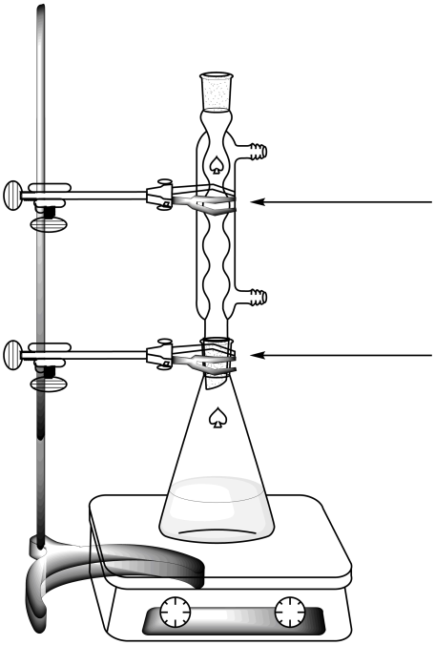
- Heat the reaction mixture with a gentle reflux (ca 1 drop refluxing per second) for 45 minutes. The mark on the heater corresponds to the necessary power to get a gentle reflux.
small clamp
large clamp

Figure 1. Setup for heating the reaction mixture under reflux

- Then turn off the heating on the hotplate stirrer. Remove the hot plate and let the reaction mixture cool down for 10 minutes. Place it afterwards in the crystallizing dish filled with an ice-water mixture. Let it stand for another 10 minutes.
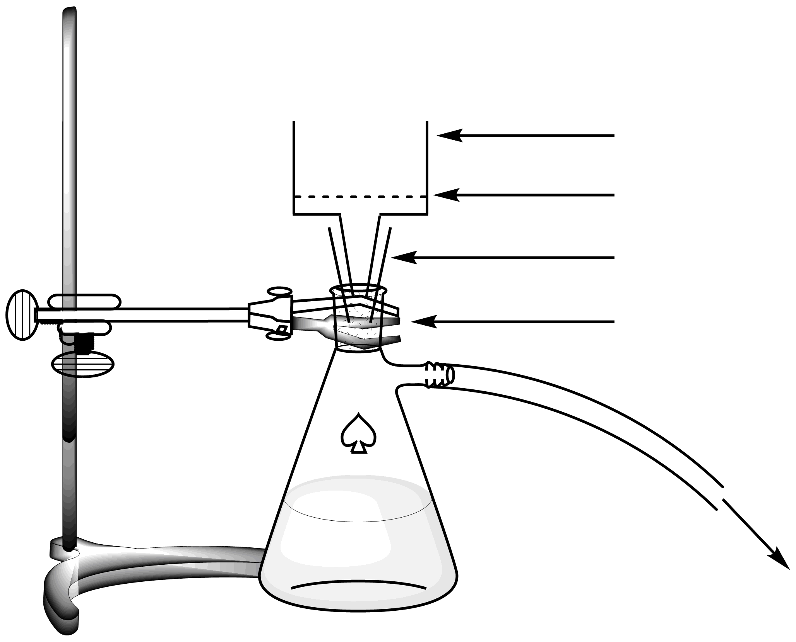
- Set up a vacuum filtration apparatus (see Figure 2) using a Büchner funnel, a filter paper and a suction flask, that is secured to the laboratory stand with a small clamp. Raise your HELP card. A lab assistant will come and show how to connect the suction flask to the vacuum source.
Vacuum
Rubber adapter
Small clamp
Filter paper
Büchner funnel

Figure 2. Setup for the vacuum filtration
- Wet the filter paper with water and ensure that it covers all the holes of the Büchner funnel.
- Pour the suspension of the crude product into the Büchner funnel and apply vacuum. Wash the solid thoroughly with deionized water (at least 4×20 mL).
- Let air suck through the precipitate for 5 minutes to pre-dry the product. Disconnect the vacuum source. Use the small spatula to transfer one tip of spatula of the product in the 1.5 mL amber glass vial, labeled C. Close the vial and save it for part III.
- Transfer all of the remaining solid into the 50 mL ground-joint Erlenmeyer flask.
- Discard the filtrate in the “Organic waste” bottle and wash both the suction flask and the Büchner funnel with ethanol and water. Use the “Organic waste” bottle to dispose of ethanol waste.
- Recrystallization of the product
- Mix 9 mL of water and 21 mL of ethanol.
- Perform the recrystallization of the crude product contained in the 50 mL ground-joint Erlenmeyer flask with the appropriate amount of this water/ethanol mixture, using the same setup as for the reflux heating (see Figure 1). Raise your HELP card. A lab assistant will come to turn on the water and set the hotplate. Add the solvent by the top of the condenser.
- Once the product has crystallized, use the same procedure as described previously (I.7 to I.10) to collect the solid. Use the small spatula to transfer one tip of spatula of the recrystallized product in the 1.5 mL amber glass vial, labeled R. Close the vial and save it for part III.
- Transfer the purified solid in the pre-weighed vial labeled with your Student Code. Close the vial.
- Discard the filtrate in the “Organic waste” bottle and raise your HELP card. A lab assistant will come to turn off the water of the condenser.
- TLC analysis
- Prepare the elution chamber. Load the elution chamber with ca 0.5 cm in height of eluent A. Cover it with a Petri dish. Wait for the eluent to saturate the atmosphere in the elution chamber.
- Prepare your samples. You are provided a sample of 4-nitrobenzaldehyde in an amber glass vial labeled TLC standard (referred as S on the TLC). You have also kept a small sample of your crude product (vial C) and your recrystallized product (vial R) in two other amber glass vials. Add ca 1 mL of ethanol in each of the vials in order to dissolve the samples.
- Prepare your TLC plate. Use a pencil to draw carefully the start line (1 cm above the bottom of the plate) and mark the positions in order to spot the 3 samples. Label them S (Starting material), C (Crude product) and R (Recrystallized product), as described in Figure 3. On the top left of the plate, write your Student Code. On the top right of the plate, write the eluent you use (first Eluent A, then Eluent B). Spot the three samples on the plate, using capillary spotters.
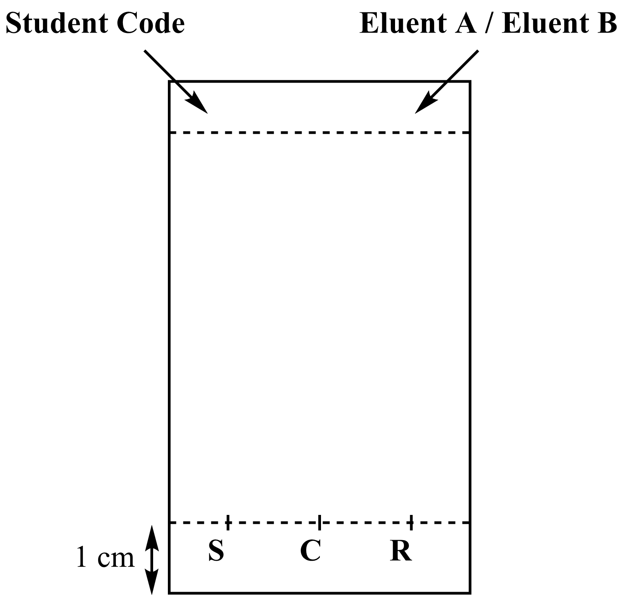
Figure 3. TLC plate preparation
- Perform the TLC analysis. Using tweezers, insert the TLC plate into the elution chamber and cover it with the Petri dish. Let the eluent reach approximately 1 cm below the top of the plate. Using tweezers, remove the plate, mark the eluent front with a pencil and let the plate air-dry.
- Visualize the TLC plate. Place the TLC plate under the UV lamp kept on the common bench. With a pencil, circle all the visible spots.
- Discard the eluent into the “Organic waste” bottle.
- Repeat steps 1, 3, 4, 5, and 6 with eluent B.
- Place your plates in the zipped bag with your Student Code.

Results of your TLC analysis (complete the schemes with your results). You may use these drawings to make a scheme of your TLC plates that may help you answer the following questions. The scheme will not be graded.
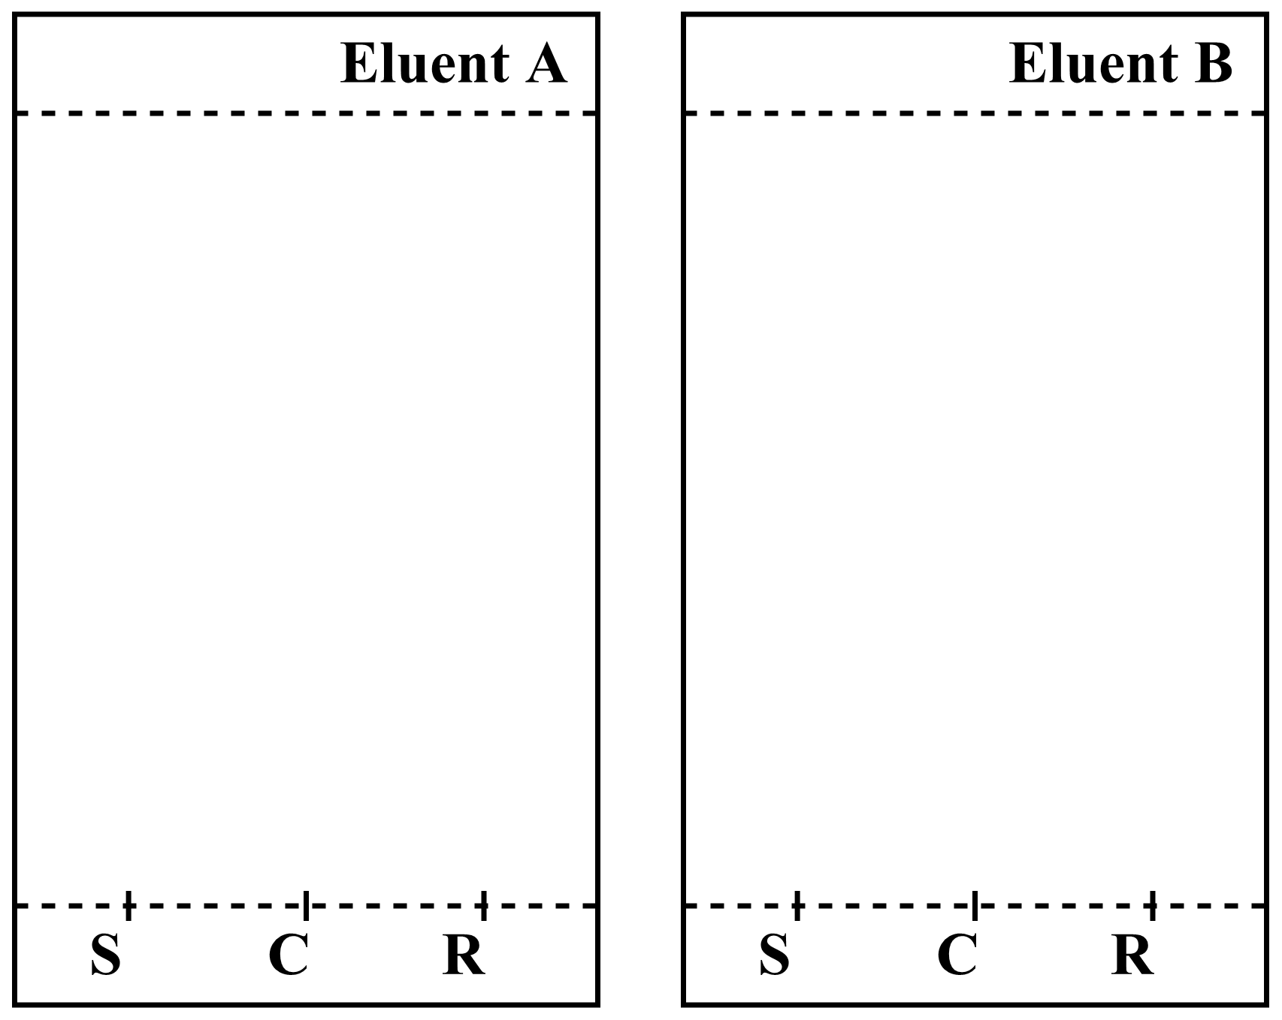
At the end of the examination, your lab supervisor will pick up the following items:
- Glass vial labeled with your Student Code containing your recrystallized product;
- TLC plates A and B in zipped bag labeled with your Student Code.

Submitted items
Recrystallized product □
TLC plate A □
TLC plate B □

Signatures
Student Lab Supervisor

Questions
- Propose a structure for the final organic product from the reaction of 4-nitrobenzaldehyde and Oxone®.

- Based on your results on the TLC analysis, answer the following questions.
- Which eluent is better to follow the reaction progress?
□ A □ B
- The crude product (C) contains traces of 4-nitrobenzaldehyde.
□ True □ False
- The recrystallized product (R) contains traces of 4-nitrobenzaldehyde.
□ True □ False

Problem  P2  14% of total | Question | Calibration | Iron determination | P2.1 | P2.2 | P2.3 | Stoichiometry determination | P2.4 | P2.5 | Total
 | Points | 10 | 6 | 3 | 4 | 3 | 9 | 3 | 2 | 40
 | Score
Problem P2. The iron age of wine
Iron is an element which can naturally be found in wine. When its concentration exceeds 10 to 15 mg per liter, iron(II) oxidation into iron(III) may lead to quality loss, through the formation of precipitates. It is therefore necessary to assess the iron content of the wine during its production.

Given the very low concentration of iron species, a colored complex of iron(III) with thiocyanate SCN‒ as a ligand is used to quantify the iron amount, through spectrophotometric measurements.

Your task is to determine the total iron concentration of the white wine provided, using spectrophotometry, and to determine the stoichiometry of the thiocyanate – iron(III) complex.

WARNING
- In this task, you are provided with two iron(III) solutions and two potassium thiocyanate solutions of different concentrations. Be very careful not to confuse them.
- Once the solutions are ready for spectrophotometric measurements, record the absorbance no later than one hour after the addition of thiocyanate.
- When you need a colorimeter, raise your HELP card. A lab assistant will give you a colorimeter labeled. You will have the exclusive use of this colorimeter for up to 15 minutes. The lab assistant will take it back as soon as you have finished or when the 15 minutes are over. If no colorimeter is available at the precise moment, you will be added to a waiting-list.
- Instructions for the colorimeter are presented on the following page.
- You can call for the colorimeter only three times for this problem.

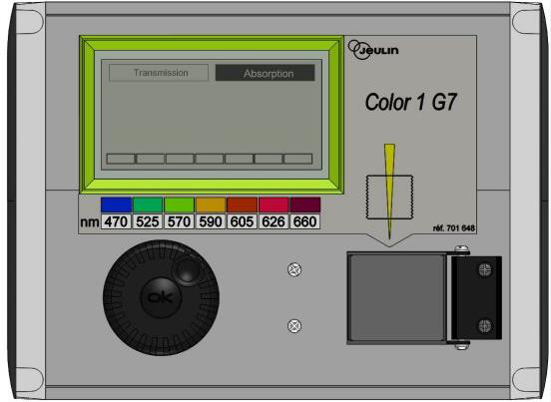
Instructions for the use of the colorimeter
Display
Absorbance/transmittance mode
Wavelength selection
Selection wheel
OK button
Orientation scheme
Cuvette tank

- Plug in the colorimeter.
- Check that “Absorbance” is highlighted. If not, turn the selection wheel until a dashed line appears around “Absorption” and then press the OK button.
- Turn the selection wheel until a dashed line appears around the desired wavelength (470 nm). Press the OK button.
- Place the cuvette with ca 3 cm in height of the blank solution in the tank. Be careful to choose the correct orientation (look at the orientation scheme on the colorimeter, the beam is in the direction of the yellow arrow, see figure below), and to push the cuvette down until the final position. Close the lid.
- Turn the selection wheel until a dashed line appears around “Absorbance” and then press the OK button. Using the selection wheel, highlight “Calibration” and press the OK button.
- Wait until the display reads 0.00 (or ‒0.00).
- Place the cuvette with ca 3 cm in height of the analyzed solution in the tank. Close the lid.
- Read the absorbance value.
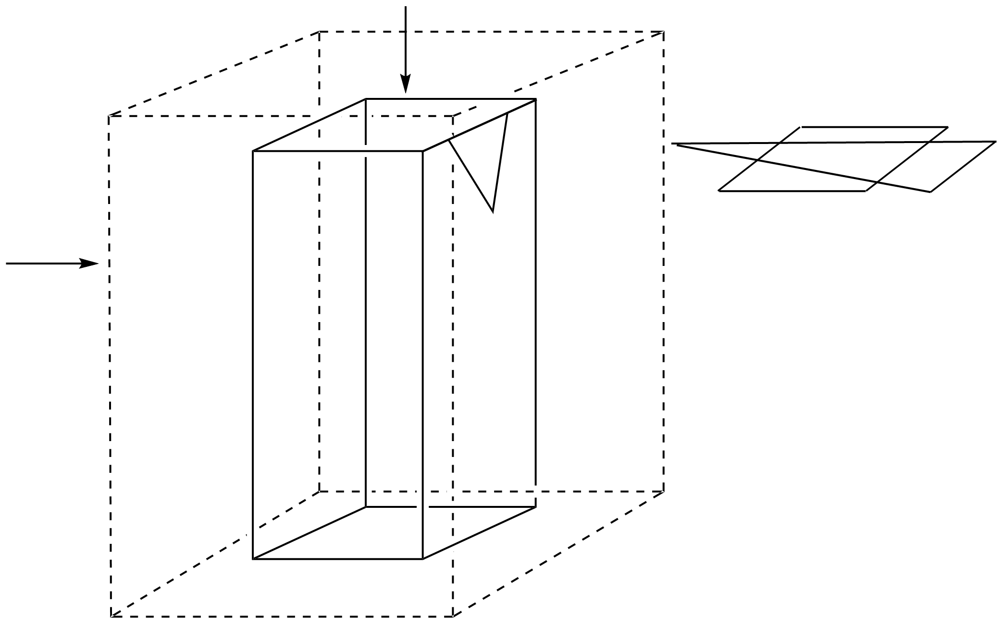
Cuve tank
Cuvette
Orientation scheme

- Determination of the iron content in the wine
In this part, you will need the 0.000200 M iron(III) solution and the 1 M potassium thiocyanate solution.
Procedure
- Prepare 6 tubes by adding to each tube the required volumes of the provided solutions, as described in the table below.
Tube # | 1 | 2 | 3 | 4 | 5 | 6
0.000200 M iron(III) solution | 1.0 mL | 2.0 mL | 4.0 mL | 6.0 mL
1 M perchloric acid solution | 1.0 mL | 1.0 mL | 1.0 mL | 1.0 mL | 1.0 mL | 1.0 mL
Wine |  |  |  |  | 10.0 mL | 10.0 mL
Hydrogen peroxide solution |  |  |  |  | 0.5 mL | 0.5 mL
Deionized water | 9.5 mL | 8.5 mL | 6.5 mL | 4.5 mL |  | 1.0 mL
- Stopper the tubes and homogenize.
- Add 1.0 mL of 1 M potassium thiocyanate solution in tubes 1, 2 3, 4 and 5. Do not add in tube 6. Stopper and homogenize.
- When all the tubes are ready, raise your HELP card to get a colorimeter from a lab assistant.
- Prepare the colorimeter using the procedure described previously (see page 16). Set the wavelength at 470 nm. Use deionized water for the blank.
- Record the absorbance of each tube (1 to 6) at this wavelength. Report the results in the following table. Raise your HELP card to return the colorimeter.
Tube # | 1 | 2 | 3 | 4 | 5 | 6
Absorbance (at 470 nm)
Analytical concentration of Fe³⁺ in the tube c(Fe³⁺) / µM | 16 | 32 | 64 | 96
Colorimeter code

Questions
- Plot the absorbance A of tubes 1 to 4 as a function of the analytical concentration of Fe³⁺ in the tube.
- In the following, check the boxes of the data you will consider for your calibration curve.
Tube # | 1 | 2 | 3 | 4
Absorbance values used for the calibration curve
- Using the previous plot and the data you have chosen, draw the calibration straight line on the previous plot determine the analytical concentration (in µmol L^{‒1}) of Fe³⁺ in tube 5.

c(Fe³⁺)_{TUBE 5} = µmol L^{‒1}
If you could not calculate c(Fe³⁺), the value c(Fe³⁺) = 50 µmol L^{‒1} can be used in the rest of the problem.
- Calculate the mass concentration, in mg per liter, of iron in the studied white wine.

c_{m}(iron) = mg L^{‒1}

- Determination of the complex stoichiometry
In this part, you will need the 0.00200 M iron(III) solution and the 0.00200 M potassium thiocyanate solution.
Procedure
In part I of this problem, we use the color of the iron(III)-thiocyanate complex to determine the concentration of iron in the sample of wine. Part II of this problem aims at investigating the stoichiometry of the [Fe_{a}(SCN)_{b}]^{(3a‒b)+} complex (coordination of water is not shown), where a and b are integers no greater than 3.

You are provided with the following aqueous solutions for this part:
- 0.00200 M iron(III) solution (already acidified) (80 mL)
- 0.00200 M potassium thiocyanate solution (80 mL)
You also have test tubes (with stoppers that you can wash and dry), graduated pipettes, a spectrophotometer cuvette, a colorimeter (upon request), and any other labware on your bench that you think useful.
- Fill the first three lines of the following table with volume values that will allow you to determine the stoichiometry of the complex, by spectrophotometric measurements. You don’t have to fill all the columns. Calculate the molar fraction of iron(III) in each tube, using the following formula.
$$x\left({Fe}^{3+}\right)=\frac{V_{Fe(III)}}{V_{Fe\left(III\right)}+V_{{SCN}^{-} }}$$
Tube # | 7 | 8 | 9 | 10 | 11 | 12 | 13 | 14 | 15
Volume of 0.00200 M iron(III) solution V_{Fe(III)} / mL
Volume of 0.00200 M potassium thiocyanate solution V_{SCN‒} / mL
Molar fraction in iron(III) x(Fe³⁺)
Absorbance (at 470 nm)
Colorimeter code
- Prepare the tubes. When all the tubes are ready, raise your HELP card to get a colorimeter from a lab assistant.
- Prepare the colorimeter using the procedure described previously (see page 16). Set the wavelength at 470 nm. Use deionized water for the blank.
- Record the absorbance of each tube at this wavelength. Report the results in the previous table.

Questions
- Plot the absorbance A of the tubes as a function of the molar fraction of iron(III) x(Fe³⁺).
- Based on the results of the experiments you carried out, determine the stoichiometry of the complex [(Fe)_{a}(SCN)_{b}]^{(3a‒b)+}.

a = b =

Problem  P3  13% of total | Question | Titration I | Titration II | Titration III | P3.1 | P3.2 | P3.3 | P3.4 | P3.5 | Total
 | Points | 10 | 10 | 8 | 4 | 4 | 2 | 2 | 2 | 42
 | Score
Problem P3. Wine for keeping
Sulfur dioxide, SO₂, is used as a preservative in wine. When SO₂ is added to wine, it can react with water leading to bisulfite ions, HSO₃‒, and protons, H⁺. Bisulfite can also be converted to sulfite, SO₃^{2‒}, by the loss of a second proton.

SO₂ + H₂O = H⁺ + HSO₃‒
HSO₃‒ = H⁺ + SO₃^{2‒}

These three different forms of sulfur dioxide in water can react with chemicals in wine such as acetaldehyde, pigments, sugars, etc. forming products P. The total concentration of sulfur dioxide is the sum of the concentration of the “free” forms (SO₂, HSO₃‒ and SO₃^{2‒}) and P.

The preservative concentration is regulated because sulfites and sulfur dioxide can be harmful to some people. In the EU, the maximum total sulfur dioxide content is set at 100 mg L^{‒1} for red wine and 150 mg L^{‒1} for white or rosé.

Your task is to determine the total sulfur dioxide concentration of the provided white wine by iodometric titration.

Procedure
- Standardization of the sodium thiosulfate solution
- You are given a sample of ca 100 mg of pure potassium iodate KIO₃. The exact mass is written on the label of the vial. Report it in the table below.
- Prepare 100 mL of potassium iodate solution in the 100 mL volumetric flask, using the whole sample of solid potassium iodate and deionized water. This solution is called S.
- In a 100 mL Erlenmeyer flask, add:
- 20 mL of solution S with a volumetric pipette;
- 5 mL of the potassium iodide solution (0.5 M), using a 5 mL graduated cylinder;
- 10 mL of the sulfuric acid solution (2.5 M) with a 10 mL graduated cylinder.
- Swirl the Erlenmeyer flask, cover it with Parafilm and keep it in the cupboard for at least five minutes.
- Fill the burette with the provided thiosulfate solution using a beaker. Titrate the content of the Erlenmeyer flask with constant swirling. When the liquid turns pale yellow, add ten drops of the starch solution and keep titrating until the solution becomes colorless. Record the titration volume V₁.
- Repeat the procedure (steps 3-5) as needed.

Mass of potassium iodate
(report the value on the label)
Analysis n° | V₁ / mL
1
2
3
Reported value V₁ / mL
- Standardization of the iodine solution
- With a volumetric pipette, transfer 25 mL of the iodine solution labeled I₂ into a 100 mL Erlenmeyer flask.
- Titrate the content of the Erlenmeyer flask with the sodium thiosulfate solution. When the liquid turns pale yellow, add ten drops of the starch solution and keep titrating until the solution becomes colorless. Record the titration volume V₂.
- Repeat the procedure (steps 1-2) as needed.

Analysis n° | V₂ / mL
1
2
3
Reported value V₂ / mL
- Determination of total sulfur dioxide
- With a volumetric pipette, transfer 50 mL of wine into a 250 mL Erlenmeyer flask.
- Add 12 mL of the sodium hydroxide solution (1 M), with a 25 mL graduated cylinder. Cover the flask with Parafilm, swirl the content then let it stand for at least 20 minutes.
- Add 5 mL of the sulfuric acid solution (2.5 M), and ca 2 mL of starch solution using a graduated disposable plastic pipette.
- Titrate the content of the Erlenmeyer flask with the iodine solution in the burette, until a dark color appears and persists for at least 15 seconds. Record the titration volume V₃.
- Repeat the procedure (steps 1-4) as needed.

Analysis n° | V₃ / mL
1
2
3
Reported value V₃ / mL

Questions
- Write down the balanced equations of all the reactions occurring during the standardization of the sodium thiosulfate solution.
- Calculate the molar concentration of the sodium thiosulfate solution. The molar mass of potassium iodate is M(KIO₃) = 214.0 g mol^{‒1}.

c(S₂O₃^{2‒}) = mol L^{‒1}
If you could not calculate c(S₂O₃^{2‒}), the value c(S₂O₃^{2‒}) = 0.0500 mol L^{‒1} can be used in the rest of the problem.
- Calculate the molar concentration of the iodine solution.

c(I₂) = mol L^{‒1}
If you could not calculate c(I₂), the value c(I₂) = 0.00700 mol L^{‒1} can be used in the rest of the problem.
- Write down the equation of the reaction between iodine I₂ and sulfur dioxide SO₂, assuming that sulfur dioxide is oxidized into sulfate ions SO₄^{2‒}.
- Calculate the mass concentration, in mg per liter, of total sulfur dioxide in the wine. The molar mass of sulfur dioxide is M(SO₂) = 64.1 g mol^{‒1}.

c_{m}(SO₂) = mg L^{‒1}

PENALTIES
Incident # | Student signature | Lab supervisor signature
1 (no penalty)
2
3
4
5

